Wenzao Ursuline University of Languages
On-Campus Dormitory
文藻外語大學 ①校內宿舍住宿需知

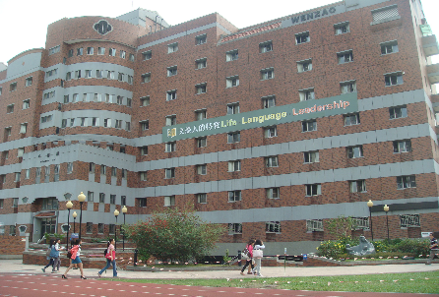
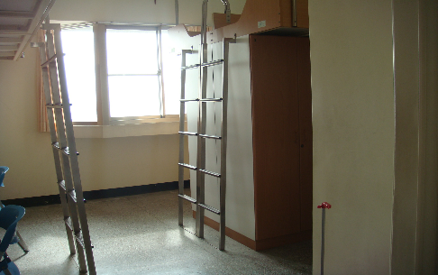
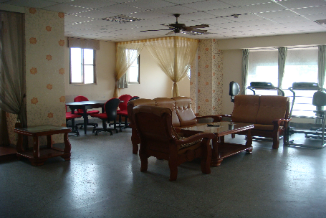

- The fee of the accommodation for one semester is NTD 12,000 and for one academic year is NTD 24,000 (not include summer and winter vacations). You have to pay NTD 5,000 deposit. After the end of the academic semester, we will return NTD 5,000 back to you.
一學期住宿費用為新台幣12,000元﹔一學年住宿費用為新台幣24,000元（不含寒假及暑假），另繳新台幣5,000元保證金（保證金將於學年結束時退回）。
- Due to the limited capacity of on-campus dormitory (4 persons per room), please remit dormitory fee (NTD 17,000/semester) in advance to make a reservation. You may choose to pay in either currencies: NTD 17,000 or USD 550.
由於宿舍床位有限，敬請先繳納住宿費用以確保住宿名額。可自己選擇繳納幣別為台幣17,000元或者美金550元。
Since the foreign remittance will cause additional handling fee, please absorb the fee. And if there is any difference, you will be asked to pay when you arrive.
由於國外匯款會有手續費用，請匯款人自行吸收。
若押金匯款不足，我們將於您抵臺時要求繳清押金金額。
- Each room is a suite for four people, including independent bed, desk and wardrobe. Furthermore, there are two rooms for students with disabilities, each suite for three students.
每間寢室均為四人住套房，床鋪、書桌、衣櫃為獨立組合式。另為行動不便學生住宿，在男女生宿舍，各有二間身心障礙學生寢室，每間住三人。
- There is a studying room on each floor, which provides students with an comfortable environment to study and surf on the net.
各樓層均設有一間自修室，提供住宿生上網查詢資料及夜讀自修場所。
- The dormitory is equipped with air-conditioning (tenants need to buy the card) and 24hours hot water supply.
全棟宿舍採中央空調〈需自購點數，刷卡計費使用〉，熱水24小時供應。
- Curfew hours are from 23:00 to 06:30. Only entering is allowed after 22:30.
門禁時間：23:00 ~ 06:30，23:00前必須返校，早上06:30開門。
如果超過22:30，B1大門只能進來不能出去。
- If you want to stay overnight outside the dormitory, hand in the Regular Late Return Application to the office before 22: 00.
如果要外宿，請於22:00外出前完成住宿生定期晚歸申請單並交至辦公室。
- Room check randomly and evaluation will be performed from Monday through Thursday.
週一到週四抽檢寢室內外務並評分。
- At the end of every semester, the room cleaning must be thoroughly conducted before moving out. NTD 500 will be deducted as the charge of cleaning in case that the cleaning result does NOT meet the inspector’s requirements.
請於學期結束離開前，完成宿舍之清潔工作。打掃不合格者將從保證金中提撥五百元，作為清潔管理費用。
- Without teacher’s consent, changing room or bed allocated is not allowed.
住宿床位經分配後未經管理單位同意不得變更位置。
- The deposit shall not be returned to those who move out for personal reason during the semester.
因個人因素中途退宿者，一律不歸還保證金。
- Smoking, alcohol, gambling and lighters are strictly banned on campus and dormitory.
校園及宿舍嚴禁抽菸、喝酒、賭博及打火機。

For more information, please check the below website: http://c012.wzu.edu.tw/category/134992#

Wenzao Ursuline University of Languages
Contracted Off-Campus Daya International Apartment
文藻外語大學 ②校外宿舍-達亞國際e化大樓住宿需知

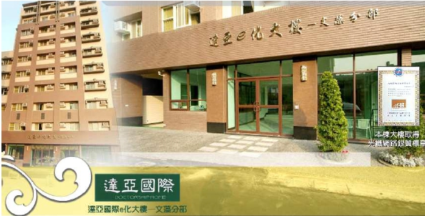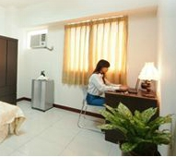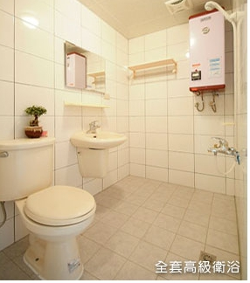
- Accommodation:
Room Type | Rental/ per month | Deposit | Provided Equipment
Small single room | NTD 5,800 | NTD 6,800 | Bed (no mattress), desk, chair, fridge, air-conditioner, internet, wardrobe, sanitary equipment, telecom and fire detection facilities.
Big single room | NTD 6,800 | NTD 6,800
Room for two | NTD 7,800 | NTD 6,800

※Rental does not include electricity cost and water fee.
房租不含水電費。
- 24 hours building managers and good security.
24小時安全管理，專人服務。
3. At the end of every semester, the room cleaning must be thoroughly conducted before moving out.
請於學期結束離開前，完成房間之清潔工作。
4. The deposit shall not be returned to those who move out for personal reason during the semester.
因個人因素中途退宿者，一律不歸還保證金。
5. 5 minutes walking distance from Wenzao Ursuline University of Languages.
文藻外語大學徒步5分鐘。
6. Address of DaYa International Apartment:
No.2, Ln. 556, Dingjinhou Rd., Sanmin Dist., Kaohsiung City 807,Taiwan (R.O.C.)
達亞地址：807高雄市三民區鼎金後路556巷

For more information, please check the below website:
http://www.daya-international.com.tw/Kaohsiung/room.html

達亞大樓住宿訂房單
Daya Reservation Form
申請人  Applicant |  |  | 國家Country
申請人  Applicant |  |  | 身分Identity |  | □學位學生  Overseas degree students  □交換學生  Overseas exchange students
電子郵件Email |  |  |  | 電話  Phone number
抵達日期  Arrival Date | 月(Month)日(Day) 年(Year)  / / |  |  | 離開日期  Departure Date | 月(Month)日(Day)年(Year)  / /
租期  Period of stay |  |  | 預定入住時間  Check-in Time
租期  Period of stay |  |  | 預定退房時間  Check-out Time
訂房間數  Number of Room/Deposit | 小單人房Small Single room □ NT$5800 間Room(s)  大單人房Large single room □ NT$ 6800 間Room(s)  雙人房 Room for two (two single beds) □ NT$7800 間Room(s)
付款人  Payer | □申請人 Applicant  □申請人家人/親友  Student’s parents/Friends |  | 付款人姓名Payer’s name
付款方式  Type of Payment | 轉帳Remittance  帳戶號碼Account number: 193540056887  帳戶名Account name: DIA INTERNATIONAL ENTERPRISE ,LTD  銀行代碼Bank code:822  銀行國際代碼Swift code: CTCBTWTP193  銀行名Bank Name: CTBC Bank Co., Ltd. (Jiouru Branch)  銀行地址Bank address:  1F., No.551, Jiuru 1st Rd., Sanmin Dist., Kaohsiung City 807, Taiwan (R.O.C.)  ★Please fill in the Remittance Application Form carefully to avoid remittance failed.  ★After the remittance is completed, please send the remittance receipt with the reservation form to Daya International Apartment.
申請人簽名  Signature of Applicant |  | 達亞大樓  Signature of Daya International Apartment

訂房須知:
1.)訂房專線電話：+886-73473826 e-mail: daya12921163@gmail.com
2.)Check in時請出示身分證(護照)辦理登記，並同時付清房款。
3.)訂房期間至少4個月以上。
4.)到達後，請繳交至少4個月以上之房租。若有問題，請事先告知。
5.)房內禁煙。
6.)由於國外匯款會有手續費用，請匯款人自行吸收。若押金不足，請您於抵達時補齊押金金額。

Reservation Information:
1.) Reservation phone number : +886-73473826 e-mail: daya12921163@gmail.com
2.) Please show your ID (passport) and pay the rental when you check-in.
3.) At least a four-month contract of renting.
4.) When you arrive, please pay at least 4 months for the first payment. If there is a problem with the payment of rent, please let us know in advance.
5.) No smoking is allowed.
6.) Since the foreign remittance will cause additional service fee, please absorb the fee. And if there is any difference, you will be asked to pay when you arrive.

Feel free to contact Daya if you have any questions.

Line ID:
Wenzao Ursuline University of Languages
On-Campus Dormitory/
Contracted Off-Campus Daya International Apartment Application
文藻外語大學 境外交換生住宿申請表
姓名Name: ____________________________
住宿地點 On/Off-Campus | 費用 Price
校內宿舍  On-campus Dormitory | □四人房 Room for four  （一學期住宿費用為新台幣12,000元﹔一學年住宿費用為新台幣24,000元，不含寒假及暑假）  One semester is NTD 12,000 and for one academic year is NTD 24,000 (not include summer and winter vacations)
校外宿舍-達亞國際e化大樓  Contracted Off-campus  Daya International Apartment | □小單人房 Small Single Room  (NTD 5,800/ per month)  □大單人房 Big Single Room  (NTD 6,800/ per month)  □雙人房 Room for two  (NTD 7,800/ per month)

I, ______________________________ (full name) hereby confirm to stay at:
□On-campus Dormitory
One academic year is NTD 24,000 (not include summer and winter vacations)

□Off-campus at Daya International Apartment
Rental fee: NTD 5,800-7,800 /per month (not include electricity cost and water fee)

I also hereby assert that I have read the On-Campus Dormitory Regulations/Contracted Off-Campus Daya International Apartment Regulations and agree to obey the regulations during my stay at the dormitory. Should I do anything against the regulations, I will accept the penalty as stated in the regulations.


I understand that the deposits shall be refunded to me on condition that the check-out procedure is duly completed.

Signature:
Date: (yyyy/mm/dd)

